Class Task

// File: LibrarySystem.java
// This program demonstrates a simple library system with two classes.
// Comments are added to analyze if they are retained after decompilation.

class Book {
String title;
String author;

// Constructor
public Book(String title, String author) {
this.title = title;
this.author = author;
}

// Method to display book info
public void display() {
System.out.println("Book: " + title + " by " + author);
}
}

public class LibrarySystem {
public static void main(String[] args) {
// Creating an instance of Book
Book b1 = new Book("Java Basics", "John Doe");
System.out.println("Starting Library System...");
b1.display();
}
}

Output
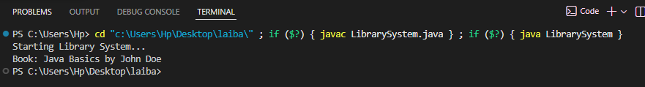

Java decompiler online tool
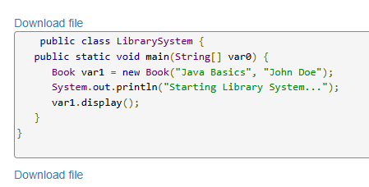
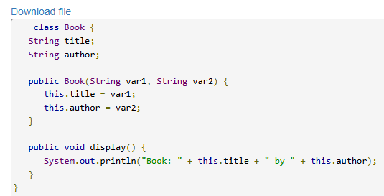

Accuracy: The decompiler was highly effective, reconstructing the logic, class structures, and method signatures perfectly.
Variable Names: Local variable names like b1 were renamed to var1, indicating loss of original local variable naming during compilation.
Comments: All original comments (//) were removed. The decompiler only reconstructs the executable code, not the comments.
Helpfulness: The tool is very helpful for understanding the logic of a compiled .class or .jar file. It allows developers to see the code structure, though it cannot recover the original comments or exact variable names.
Conclusion: The tool helps to recover the logic for reverse engineering, but cannot reconstruct the original source file entirely.

